Charity Fischer
METC143
12/13/17

Problem Statement: The task is to design a cable that will support a 60 ton vehicle. The cable is 25 foot long and can have an elastic deformation of no more than 10%. Using the Modulus of Elasticity for various metals design a cable. Use standard cable diameter sizes listed below (units are inch):
2
1 3/4
1 1/2
1 1/4
1
3/4
1/2
3/8
1/4
3/16
1/8
1/16
1/32
1/64

Introduction: Excel was used to calculate Thermal Expansion and the elastic deformation of each material and MatWeb was used to find information of the elemental components of the materials examined.
I used $∆L=∝*L*∆T$ to find the thermal expansion of each material. Where α=coefficient of thermal expansion, L= Length, and ΔT represents the change in temperature. For each material, I took the coefficient of thermal expansion and multiplied it and the length of the cable by the change in temperature in 20 degree increments up to 300 degrees Fahrenheit.
I found the percent of elongation by using the modulus of elasticity. I took the weight of the car, converted it to psi and put it into $σ=\frac{2P}{πdt}$. After finding the stress I took $E=\frac{σ}{e}$ and turned it into $l-lo=\left(\frac{σ}{E}\right)\left(lo\right)$ using Poisson’s ratio to replace e in order to find the change in length. Then I took the change in length divided by the original length and multiplied by 100 to find the percentage of elongation.
Results: The materials that were examined and their component elements, as shown in a table, are 2014-T6 Aluminum,
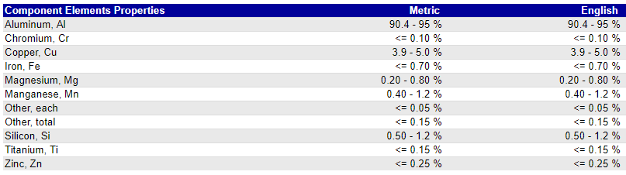
http://www.matweb.com/search/DataSheet.aspx?MatGUID=e5de9f1161d34f71a34ae016723d097f
1045 Steel,
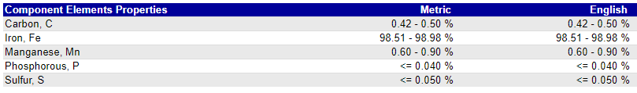
http://www.matweb.com/search/DataSheet.aspx?MatGUID=43364bf60fe843f9bd4daf66f31c2535&ckck=1
Copper,
http://www.matweb.com/search/DataSheet.aspx?MatGUID=9aebe83845c04c1db5126fada6f76f7e
And Titanium Ti-6AI-4V.
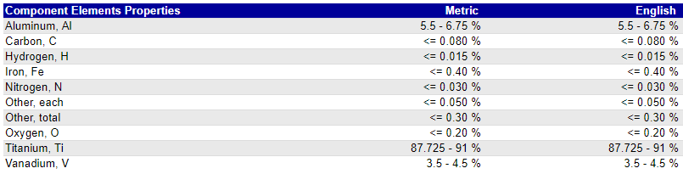
http://www.matweb.com/search/DataSheet.aspx?MatGUID=a0655d261898456b958e5f825ae85390&ckck=1
The following graph is the stress calculated by $σ=\frac{2P}{πdt}$ where P is 120000 psi, d is each diameter, and t is 25 feet. I used this stress in calculating the fatigue for 2014-T6 Aluminum and 1045Steel.

Fatigue Analysis:
For 2014-T6 Aluminum at 3/8 of an inch the stress was 8,148.73 which, according to the chart above as read by me, gives it a minimum of 10^8 cycles.
For 1045 Steel at 1/8 of an inch the stress was 24,446.2 which, according to the chart above as read by me, gives it a minimum of 10^9 cycles.
Thermal Analysis: To calculate the thermal expansion I took the length of the cable, multiplied it by the change in temperature, which I took in 20 degree increments, and then I multiplied that by the coefficient of thermal expansion for each material. The following graph is a plot of what I calculated in my tables of data.

Conclusion: Based on my calculations using the weight of the car, the length required for the cable, and the Modulus of Elasticity for each material examined these are the smallest diameters that can be used per material, based on the fact that there can be no more than 10% elastic deformation. Also listed is the percent elongation for the diameter:
2014-T6 Aluminum: 3/8 inch diameter = 8.15% Elongation
1045 Steel: 1/8 inch diameter = 8.15% Elongation
Copper: 1/4 inch diameter = 8.15% Elongation
Titanium Ti-6AI-4V: 3/8 inch diameter = 6.79% Elongation
I would choose to use 1045 Steel for this project because it has the least percentage of elongation compared to the others and nearly the least thermal expansion only beat by titanium Ti-6AI-4V by 0.013725 feet at a change of 300 degrees Fahrenheit. The diameter I would pick for my 1045 steel cable is 1/4 inch diameter. While the minimum diameter I calculated per the 10% elastic deformation constraints was 1/8 It would not be a bad idea, if the steel is malleable, to give it a bit more security with a larger diameter to ensure not only the ones putting money behind this project, but also those putting their safety in the cable car will be secure in the their safety.

